**DATA VISUALIZATION WITH PYTHON**

**GRADED ASSIGNMENT**

**Check Working of the dropdown menus:**

1. **Choose Report type as ‘Yearly Airline Performance Report’ and Year as 2019**

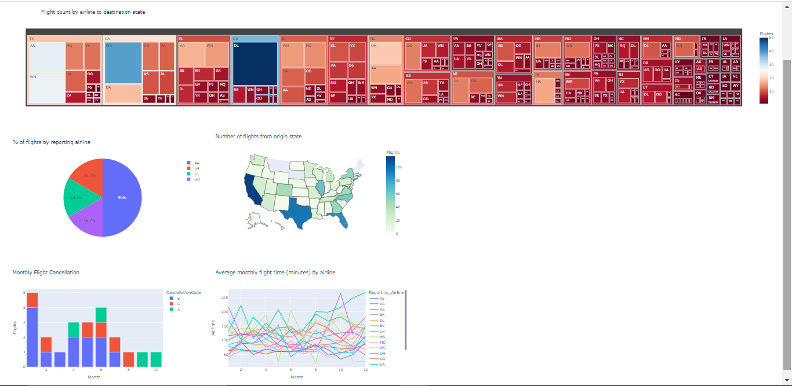

1. **Choose Report type as ‘Yearly Airline Performance Report’ and Year as 2015**

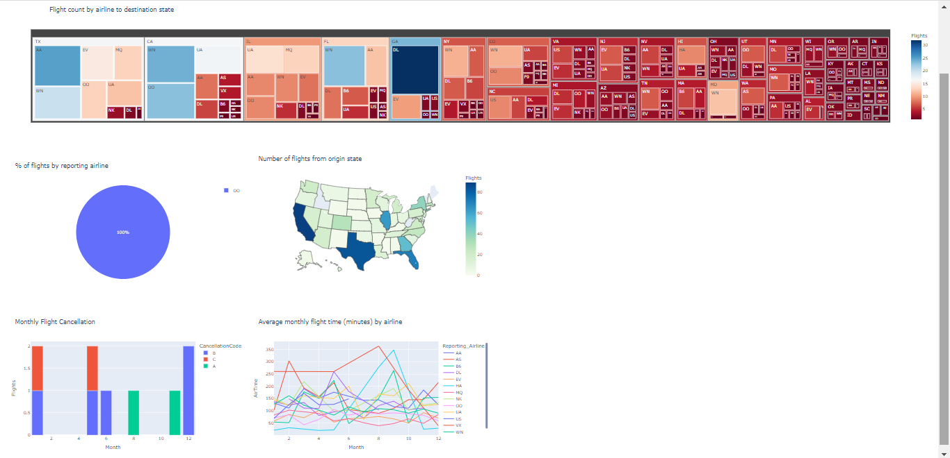

**3) Choose Report type as ‘Yearly Airline Delay Report’ and Year as 2019**

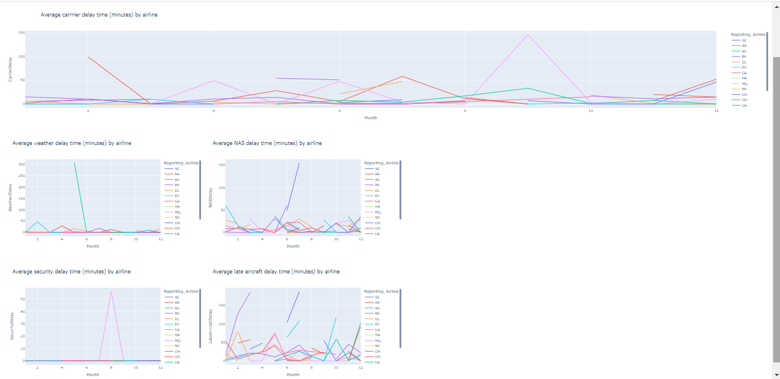

**4)Choose Report type as ‘Yearly Airline Performance Report’ and Year as 2008**

